“Nothing Means”: Aesthetic Paradigm Shift from Epistemology to Ontology

Haeyoung Youn

Kwon Ki-Chul's current exhibition is centered around color abstraction works introduced through the series "And, The Secret Narratives of Everyday Life," with the exhibition title being "Nothing Means." The title "Nothing Means" seems to offer clues for understanding his works, almost like a code. The title signifies the futility of attributing meaning, focusing on pure artistic elements such as color, form, line, and texture in abstraction. From a semantic perspective, the term "Nothing Means" could ironically reveal the artist's complex thoughts and inner emotions. However, considering the artist’s intention that "red and blue dots, lines, and colors record the special and delicate personal things," this formalistic and semantic analysis appears insufficient to fully reflect the abstract style and aesthetic practice he pursues.
Based on this issue, a shift from an epistemological to an ontological perspective in understanding "Nothing Means" is proposed as another method of interpretation. In particular, attention must be paid to Gilles Deleuze's differential ontology. Contrary to traditional ontology, which seeks to understand the fixed essence and attributes of being, Deleuze sees difference as the essential condition of being, arguing that being is a continuous process of becoming, created and changed through difference. Influenced by Friedrich Nietzsche, Deleuze defines force as the basis and principle of being, explaining the creation and change of being through the relations and differences of forces, and their interaction. In this ontological context, Deleuze mentions that art must capture forces, which are attributed to creation and change, to go beyond representation. This corresponds with Paul Klee's statement that painting is not about reproducing the visible but making visible the invisible.
On the other hand, capturing intangible and fluid forces is impossible through the conscious recognition process that relies on fixed systems or concepts. However, force can be sensed through sensation, and in this relationship, force becomes a condition for the emergence of sensation, though force itself is not sensation. In this context, sensation is understood not in its general sense but as the body's immediate response before consciousness intervenes. Sensation represents a state where force acts directly on the body, traversing various dimensions of sensation, and this phenomenon goes beyond everyday sensations. Therefore, the emergence of sensation means an ontological event that represents "being-in-the-world," as phenomenologists describe it, or the way the world is presented to us in a state of consciousness before the distinction between subject and object is made.
From an ontological perspective, Kwon’s color abstraction can be seen as the visual manifestation of the sensations experienced through his experimentation with forces. In this context, the way Kwon visually expresses sensation as an ontological event can be seen as reflecting the abstract style he pursues. Furthermore, it is intended to understand his aesthetic practice through elements such as chance, color, and space.
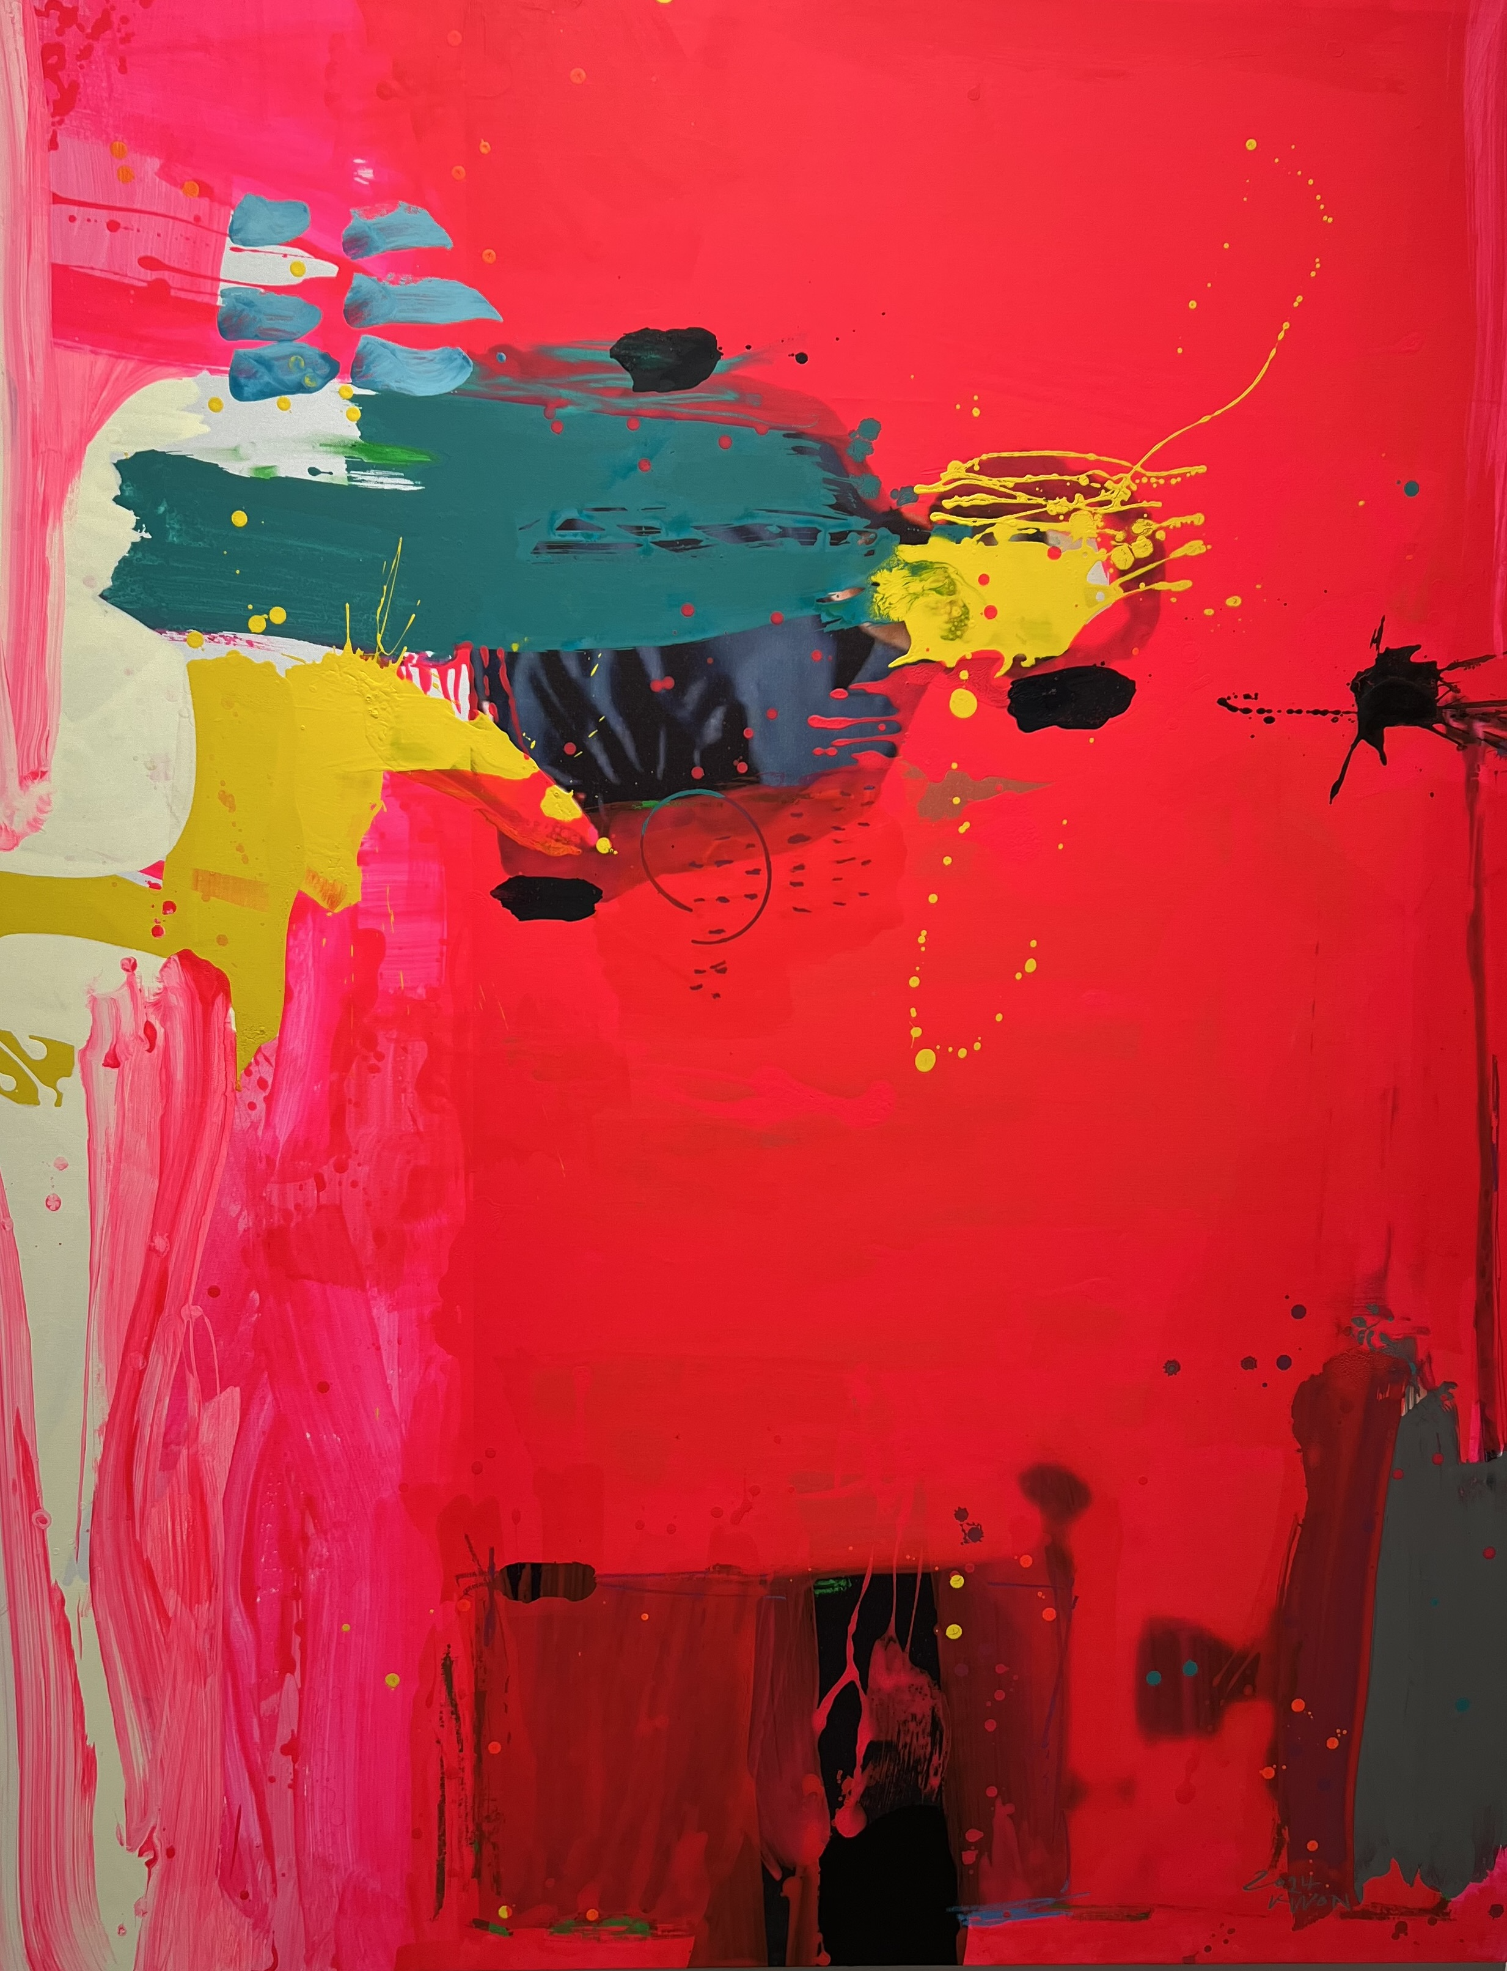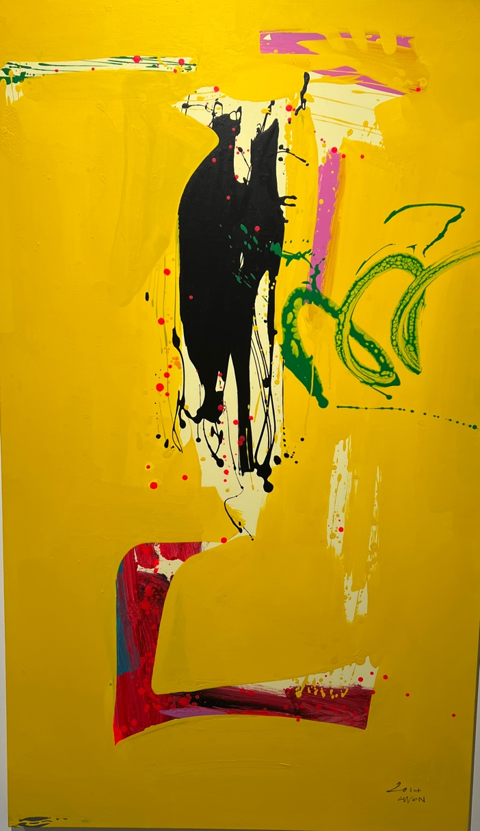

Controlled Chance
Considering Kwon’s working process, there would be a methodological exploration of "how to approach" between the attempt to record the personal through dots and lines of various colors and the act of working itself. Kwon accepts chance as an important element of the working method and mentions refining it through his critical sense.
Initially, Kwon begins his process by drawing dots and lines of various colors and shapes onto the canvas to express what he has conceived. However, when the dots and lines formed by chance do not align with his intention, he either covers them with different colors or erases them. This process does not completely exclude the element of chance but selectively controls and partially reveals it through his critical sense. Kwon moves his hand over the covered area, drawing a single stroke (一) or its variation, as shown in his ink abstraction works. Just as Kwon’s ink works are expressed through the body's intuitive gestures originating from a state of no-mind, so too are the intense colors of linear forms drawn through the free and accidental movement of the hand stemming from an unconscious state. Within his act of painting, chance is revisited, recording his personal aspects as pictorial facts through sensation.
The way Kwon deals with chance can be understood through Deleuze's concept of the diagram and its operational principles. Deleuze describes the diagram as "the set of asignifying and nonrepresentative lines and zones, line-strokes, and color-patches." It is also "the operative set of traits and color patches, of lines and zones." Within it, the accidental aspect of the emergence of chance and its evaluative and controlling aspect operate in opposition to each other. Confronted with a diagram, artists experience chaos and find their own ways to navigate through it. This experience of chaos means the artist’s experimenting with forces acting on the body and experiencing the emergence of sensation, and passing through a diagram means creating a new order based on sensation. Therefore, a diagram is defined as "a chaos, a catastrophe, but it is also a germ of order or rhythm." The onomatopoeic word "Eoiku," frequently used by Kwon, denotes an exclamation that accompanies the sudden emergence of new forms in the continuous act of painting, spraying, and rubbing with a brush. Deleuze mentions that each artist has a unique diagram; for Kwon, this could be termed his "Eoiku" diagram.

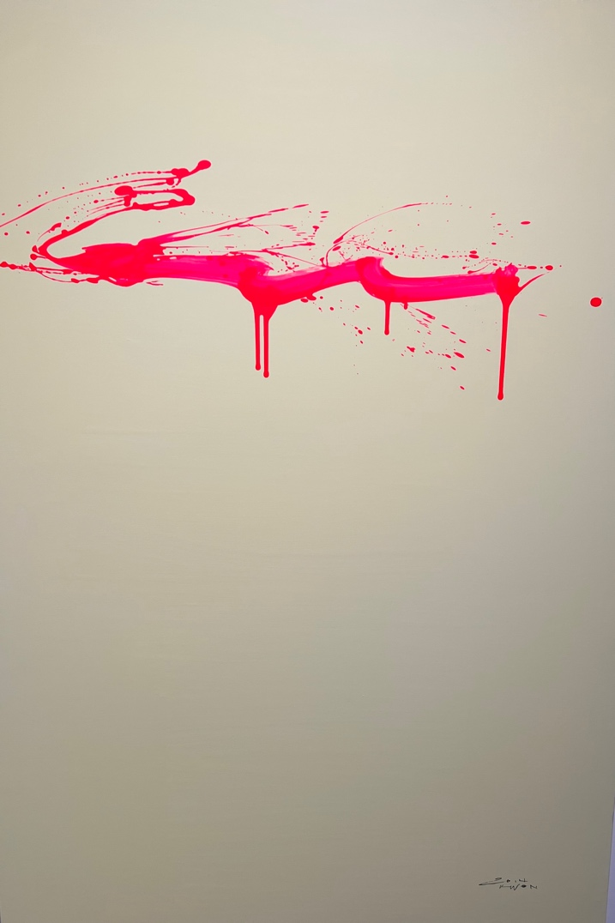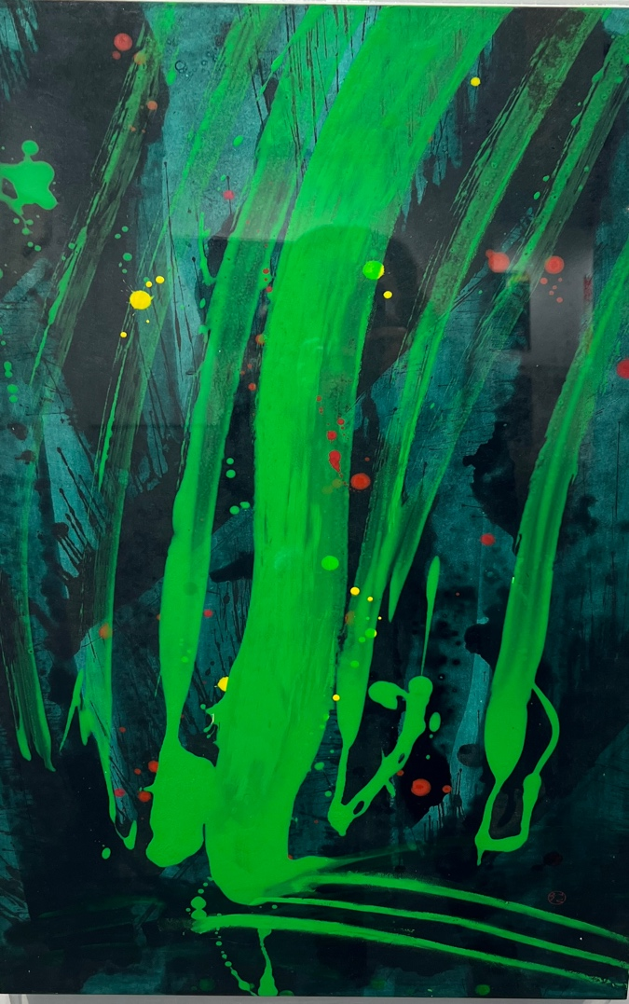

Coloring Sensation
In Kwon's color abstraction, colors are fundamentally composed of three layers. The bottom layer features a variety of dots and lines in different colors, over which a monochromatic middle layer is applied. However, this middle layer does not completely cover the bottom layer but instead partially reveals it, akin to the sgraffito technique where the top color is scraped away to expose the color beneath. This layered structure, with the vibrant bottom layer and the overlying monochromatic middle layer, provides a foundation for the final, intense color of the linear forms to be added.
Kwon’s use of color relies on the pure contrast between colors, or more specifically, on relations of tonality. Consequently, the colors applied across the three layers are juxtaposed, creating interference with one another. For example, in a work, the arrangement of black in the bottom layer, purple in the middle layer, and red on the top layer results in a continuous contrast between red against black and purple, forming a relative advancement and retreat, thereby generating spatial depth. This approach contrasts with Korean monochrome painting, where form is created through repetitive physical actions with color, and the pattern of that form is constituted on the screen through the density of colors. Furthermore, the colors are in a differential relation, meaning the property of a color changes depending on its placement next to another color. For instance, the character of red is not defined solely by its intrinsic hue but also by its interaction with black and purple. Therefore, the red spanning over black and purple changes in intensity and tone due to its relationship with these two colors. In essence, within this differential relation, colors do not remain static; they generate differences and undergo changes within themselves, placing them in a state of continuous variation.
In this context, the colors of the three layers compose forms and backgrounds on the plane through their interplay. Firstly, the color of the top layer is intense, visually compressing into linear forms through the energy it emits, while the color of the middle layer covers the bottom layer, diminishing in saturation and spreading across the screen. The various colors and dots of the bottom layer are only partially revealed, but appear distinct compared to the monochromatic top and middle layers. However, the colors of the bottom layer visible through the middle layer visually emphasize and animate the linear forms of the top layer. For example, when the top layer's red, the middle layer's black, and the bottom layer's green are arranged together, the linear form of red appears more vibrant against the black background through the complementary contrast with green. In the artwork, the iconic color contrast between the top and bottom layers that shapes the linear forms appears in combinations such as yellow and black or red and ivory. This dynamic interplay of colors across the three layers, which defines forms and backgrounds on the plane, offers a counterpoint to Color field painting that emphasizes the flatness of the canvas by prioritizing the arrangement of color planes at the forefront.

Intensive Space
The juxtaposition of colors, as revealed through the overlay of three layers partially concentrates the gaze and draws viewers closer. From this proximity, the tonal relationships of the colors creates a sense of space, achieved through depth—a depth that is different from the distant and near perceptions conveyed by perspective. This depth is not an additive dimension to length and width; rather, it is what Deleuze refers to "a groundless depth" or "spatium." Unlike Euclidean geometric space, which is measured numerically, spatium is a realm of affect that is sensed and characterized by intensity.
The intensive space created by the juxtaposition of colors is filled with force, vibrancy, and acoustic and tactile qualities such as sound and wind. In this intensive space, the eyes do more than simply see; they grope, listen, and feel, indicating a state where the body, as a sensory subject, has not yet differentiated into distinct organs. Returning to an undifferentiated state of sensory organs represents not a regression in evolution but rather a state where multiple levels of sensation, such as sight, smell, hearing, and touch, respond simultaneously to the dynamics of forces, unconfined to any single sensory organ. Consequently, Kwon’s color abstract work visually expresses primal sensations, which are the foundation of individual sensations, by engaging multiple sensations at once. As a result, in his work, one might hear the sound of wind sweeping through a dense forest, feel the softness of tender leaves, touch the froth of rough waves, and experience the heat of Icarus's wax wings melting under the sun.
This experience of synaesthesia becomes possible as viewers immerse themselves in Kwon's work and encounter its sensation. It suggests that there is no ontological distance between the work and viewers, the perceived object and the perceiving self, in contrast to perspective, which separates them from the space. Ultimately, Kwon's color abstraction evokes viewers’ affect through a space that is connected, accessed, and distributed by intensity, and this process transforms their physical capacity to affect and to be affected. This indicates that Kwon’s work produces an ontological effect and proposes a new model of art reception distinct from an epistemological approach. Kwon’s artwork is not merely an object to be understood through visual contemplation but a subject of sensory experience that demands bodily transformation. Therefore, inquiries regarding Kwon's work should shift from "What does it mean?" to "How does it function?" and "What affect does it produce?" From this perspective, the exhibition title "Nothing Means" will be a milestone indicating the aesthetic paradigm shift from an epistemological approach to ontological understanding.

